Book Project Operations

This document describes how to operate the several pieces of software that make up a project called the Book Project. This software was developed by Peter Lindes as part of an internship at Family Search in the summer of 2014. It is intended to integrate with other software developed by the Data Extraction Group (DEG) at BYU, especially the OntoSoar system.

Data Flow
To understand the Book Project (BP) software it helps to understand the overall dataflow as shown in Figure 1.

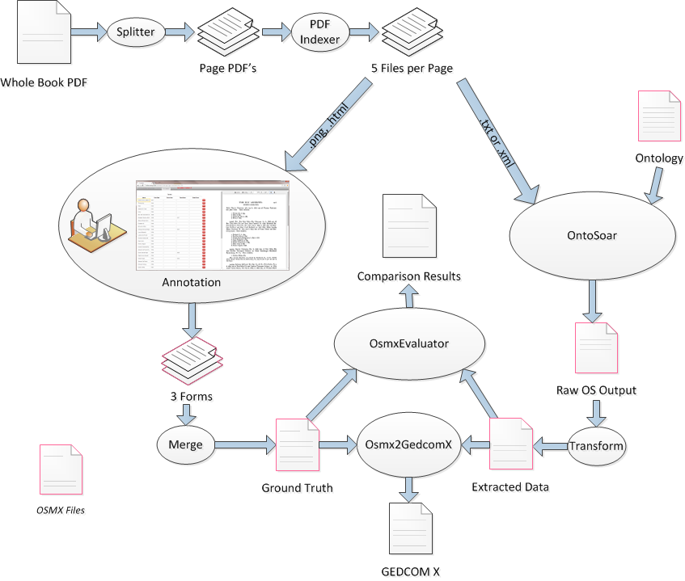
Figure 1 – Book Project Data Flow
The process begins with a book, presumably a family history book of some sort, which has been scanned into a single PDF file containing all the pages. This large PDF is split into smaller PDF’s, one for each page of the book. Then a DEG program called PDFIndexer processes each page PDF and generates four more files for that page: a .txt file containing the raw text produced by an OCR engine processing the page, a .xml file which has this text organized with bounding boxes for each character, word, and line, a .png image file that is used to display the page to the user in the Annotator, and a .html file that can overlay the .png image to show a layer of text with bounding boxes that can be clicked on to annotate the text.
From this set of five files the data flow divides into two paths, one for human annotation and one for automatic data extraction. The results of these two paths can be compared using an OsmxEvaluator tool and either or both can be converted to GEDCOM X format by the Osmx2GedcomX converter.
The human annotation path uses a tool developed by the DEG called the Annotator. It is a web-based tool that allows a user to see a screen with an image of a page on the right and a form to be filled in with data on the left. The user fills out the form by clicking on the words in the text that fill a certain field in the form. This provides an easy-to-use method for a human being to annotate each page of a book.
The current design requires one or more human annotators to annotate the same page using three different forms to get three different kinds of data. This is done because it was felt that the task is too complex to be comfortable if all the data were captured in a single form. The three forms used are: Person, which captures basic information about each individual person’s name along with birth and death information when available, Couple which captures marriages including the two spouses and date and place of the marriage if available, and ParentsWithChildren which captures family groups consisting of two parents and one or more children.
The automatic data extraction path uses one of several DEG tools for automatically extracting genealogy data from text. The Book Project work has been done exclusively with the OntoSoar tool so far, but other automatic extraction tools could be integrated as well.
OntoSoar is a system built as a master’s project at BYU by Peter Lindes. It uses the Link Grammar Parser, the Soar cognitive architecture, and custom software developed in both Java and Soar languages. Each time OntoSoar runs it takes two input files: the text of a page in either .txt or .xml form, and an ontology file defining the conceptual model in which its output should be produced. It then processes the text and populates the ontology with the data it finds, outputting the results as a populated ontology file.
At this point we should explain what OSMX files are. These are XML files using a schema developed by DEG to represent conceptual models and data to populate them. All the files with colored borders in Figure 1 are OSMX files. As the figure shows, the OSMX format is used by a number of the BP tools. However, different files are in different formats in the sense that they use different conceptual models.
For instance, each of the three form types used by the Annotator for this project has a different conceptual model to represent the particular type of data that it deals with. Also, the ontology commonly used with OntoSoar is a different one that allows most of the basic genealogy facts to be represented in a single ontology. In order for that outputs of the two data flow paths to be compared with each other, and to use a standard tool for converting from OSMX to GEDCOMX, we need a common format.
This common format is called the Family Tree ontology, and its unpopulated form is stored in a file called FamilyTree.xml. There is a tool called the OsmxMerger that knows how to convert between various ontology formats. It can perform two functions: take a set of the three annotated forms for a given page and merge them into a single OSXM file conforming to the Family Tree ontology, or take a single OSMX file in the form of the ontology that OntoSoar currently uses and transform that into a file in Family Tree form. These two functions are represented in Figure 1 by the two blogs labeled Merge and Transform.
Now that we have data from both paths in a common format, we can compare them. This is the job of the OsmxEvaluator tool. It takes two input files in the same OSMX format as input, one called the reference file and one called the test file. It first matches up the object and relationship sets between the two files, and then proceeds to check the correspondence between the individual objects and relationships. It produces an output that shows the details of these matches, and summarizes the results in terms of Precision, Recall, and F-Measure scores for each individual object and relationship set and for the page as a whole.
The last module in Figure 1 is the Osmx2GedcomX module, which takes in any OSMX file in Family Tree format and converts it to a GEDCOMX output file. The current version produces GEDCOMX <person>, <relationship>, and <event> elements with details on names, dates, and places as provided. However, it does not yet produce information on the original source document the data came from, the agent that produced it, or the position on the page where each data item was found. Providing this information requires more work by Family Search to determine how this data will be represented.
Something not shown in Figure 1 is the overall BookProject module, which can run a whole batch of data, up to an entire book, through all the processing steps at once.
The rest of this document will look at each of the BP modules in detail, explaining how to run each one from the command line and how to set up a job to be batch processed.

OntoSoar
In order to run the OntoSoar system, it first has to be installed on your machine. A file called OntoSoar.zip is available for doing this. Extract the contents of this file to a directory called OntoSoar at some convenient place on your machine and you’ll be ready to go. The directory includes a ReadMe.txt file that explains what the rest of the files are, and a RunIt.bat file that gives an example of how to run the system.
The simplest way to run OntoSoar from the command line is to type a command similar to (1):
(1) | java -jar OntoSoar.jar “Mary Ely died in 1843.”
NOTE: Don’t try to just copy the above line and paste it into your command window. For some reason the character sets are different or something, and this copy and paste does not work.
This will make OntoSoar process the sentence in quotes and produce both an OSMX file with the results and a description of its processing in the command window. To get it to process a whole file, use a command like this:
(2) | java -jar OntoSoar.jar –b data/ontosoar/MyraRaw.txt
The –b (for batch of sentences) says that the next argument is the name of the input file that contains a batch of sentences to process. This example shows a reference to one of the data files supplied in OntoSoar.zip, but this can be an absolute or relative path to any file you please. Also, this shows a .txt file as the input. You can choose to provide one of the .xml files produced by the PDFIndexer. OntoSoar will put character offsets in its output annotations for a .txt input, but if the input is .xml it will also put bounding boxes for each word in the output annotations.
Another option for OntoSoar is to specify the ontology to use. This is done with the –u option, standing for user ontology, as shown in (3).
(3) | java -jar OntoSoar.jar –b data/ontosoar/MyraRaw.txt –u knowledge/Family.xml
When OntoSoar is run, it produces its output in a file called OutputData.osmx.xml in the OntoSoar directory. You can then rename this file and move it somewhere else in whatever way you like. In addition, OntoSoar produces a lot of useful information about its processing on the standard output. You can capture this in a file by running OntoSoar with a command like this:
(4) | java -jar OntoSoar.jar –b data/ontosoar/MyraRaw.txt >out.txt
Now the console output will go to the file out.txt and you can use it as needed.

OsmxMerger
As mentioned above, the OsmxMerger module performs two important functions. It can collect the set of three form files produced by the annotator and merge them into a single OSMX file built on the FamilyTree ontology, and it can take a single OSMX file built with the Family ontology OntoSoar uses and transform into an OSMX file built on the FamilyTree ontology. The FamilyTree ontology gives a common form to compare a set of annotations with OntoSoar output in the evaluator, and it is also the form needed to convert the data into GEDCOM X.
To run a transform on a page of OntoSoar output, use a command like this:
(5) | java -jar OsmxMerger.jar -c 000Ely.config 000Ely_573.F.xml
This will transform this one file in the .F. format to one with the same name in the .FT. format, giving a file called 000Ely_573.FT.xml. The –c option is necessary to get a configuration file, whose contents will be explained below.
To merge three annotator files into a single FamilyTree file, use a command like this:
(6) | java -jar OsmxMerger.jar -c 000Ely.config 000Ely_573.C.xml 000Ely_573.P.xml 000Ely_573.PWC.xml
Of course this command has been folded over, but it is a single command line. Here we give the merger its .config file plus three other files have codes of .C., .P., and .PWC. . These codes each have both a long and a short version as the following table shows:

Short Code | Long Code | Meaning
.P. | .Person. | Data from a Person form in the Annotator.
.C. | .Couple. | Data from a Couple form in the Annotator.
.PWC. | .ParentsWithChildren. | Data from a ParentsWithChildren form in the Annotator.
.F. | .Family. | Data in the Family ontology normally used by OntoSoar.
.FT. | .FamilyTree. | Data in the FamilyTree ontology normally used as input to either the OsmxEvaluator or the Osmx2GedcomX modules.
Table 1 – File naming codes
The OsmxMerger module requires that each of its input files have one of these codes, either short or long but always surrounded by two periods, in order to tell which file is which and how to process them. For each file transformed or group of files merged its output file will have the same name as its input file except with the code changed from whatever it was to .FT. or .FamilyTree. .

OsmxEvaluator
The OsmxEvaluator will take any two compatible OSMX files and compare them to each other, printing out a detailed description of how the objects and relationships match up as well as a statistical report giving precision and recall. To run it use a command like this:
(7) | java -jar OsmxEvaluator.jar -c 000Ely.config ElyAncestry573.FamilyTree.GroundTruth.xml 000Ely_573.ft.xml
This command will compare the two OSMX files and write all the output to the console. Notice that the evaluator does not care about the form of the file names or type codes or anything of the sort. It will compare the two ontologies strictly according to their internal names for object sets and relationship sets.
At the present time the evaluator does not have an option to write its output to a file. You can accomplish this by redirecting standard out as in (4).

Osmx2GedcomX
Once you have run a document through OntoSoar, you may want to convert the output to a GEDCOM X file. In order for this to work, you first have to transform the file to the .FT. format as described above. Then just run this module as with a command like this:
(8) | java -jar Osmx2GedcomX.jar 000Ely_573.FT.xml -o 000Ely_573.gedcomx
This command gives a single input file and the form for the output file. Here the input file is a .FT. file as produced by either of commands (5) or (6). The string after the –o option is not quite a file name. This string is used to produce both an XML and a JSON version of the GEDCOM X output, in this case in the files 000Ely_573.gedcomx.xml and 000Ely_573.gedcomx.json.
When your run this command you get the following output on the console:
(9) | Converting file '000Ely_573.FT.xml' to Gedcom X.  Persons: 32, Births: 17, Deaths: 8, Genders: 4, Couples: 4, Children: 8.
This console output gives some basic statistics on the data put into the GEDCOM X file. As in (4) above, you can redirect this output to a file.

BookProject
BookProject is a program that runs all the other modules in a batch processing mode. It looks for or builds a directory structure for a whole book with several subdirectories for different kinds of files, and populates the subdirectories for the inputs to the Annotator and OntoSoar with files from a repository for that book, if such is available.
Creating annotations must be done by a human being using the Annotator, so the BookProject program cannot do that part on its own. However, if the annotations have been provided in the proper subdirectory it will run OntoSoar on all the specified pages, transform the OntoSoar output and merge the annotation files that are available, run the evaluator on all the given pages, and finally convert all the OntoSoar outputs for those pages to GEDCOM X files. The only input for it to do all of this is a configuration file, specified with a command like this:
(10) | java -jar BookProject.jar 000Ely.config
As usual, BookProject writes a bunch of output to the console, and this can be redirected to a file.

Config Files

